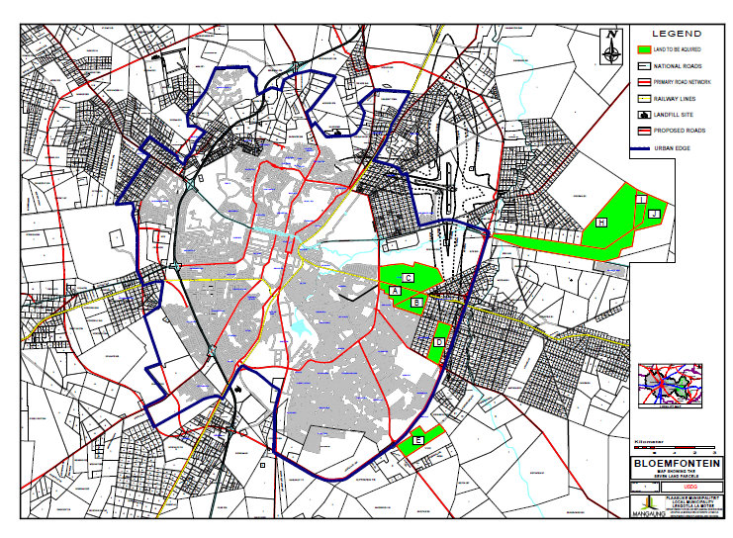

PRIORITY LAND ACQUISITION PARCELS

PLAN 6